**Python Project 3**

Use mortgages originated in Q1 2008 and Q1 2020 to compare the loan quality in the following aspects:

- Risk

* Delinquency
* Foreclosure rat
* Forbearance
  + Loan Purpose (purchase, rate refinance and cash out refinance)
  + DTI (debt-to-income)
  + LTV (loan-to-value)

In general, mortgages originated in Q1 2008 had lower quality. We want to use data to prove this.

Because the original sample is very big, we will choose two state (VA and OH) to run the analysis.

**1) Data Source 1 – mortgage data**

Take the following steps to extract the data (very similar to Project 2):

Step 1: Copy the following to Google and search

<https://capitalmarkets.fanniemae.com/credit-risk-transfer/single-family-credit-risk-transfer/fannie-mae-single-family-loan-performance-data>

Step 2: After opening the above web page, click on the following link highlighted in yellow:

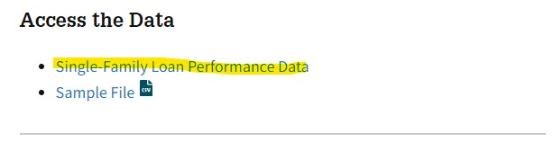

On the same page, download the following:

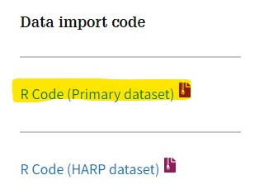

Open the R code in notepad, and you will get the list of column names for the data to be downloaded.

Step 3: Register for a free account for login by using your email.

Step 4: After you have logged in, click on the icon on the very right (in yellow highlight):



Step 5: On the top left, click on DOWNLOAD DATA:

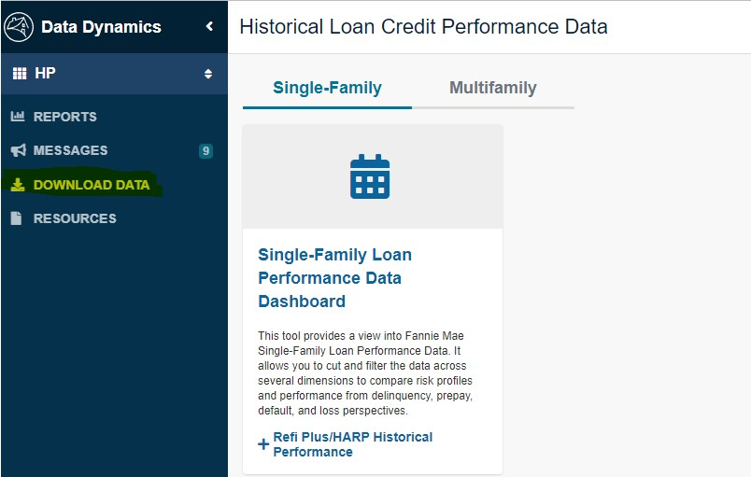

Step 6: Download files for Q1 2008 and Q1 2018.

